CMP9132M - Advanced Artificial Intelligence

Lecture 1- Introduction

2 Assignments, each worth 50% of final mark

* Assignment 1: before Christmas
* Assignment 2: at the end of module

**Quantify uncertainty – intro to probability**

**Probability reasoning - Bayesian networks, casual interference, etc.**

**Reasoning over time - Hidden Markov models, etc.**

**Making complex decisions – Markov Decision Processes etc.**

**Links AAI <--> Machine learning**

Machine learning is a sub topic of AI

Reasoning over time

* Hidden Markov models, Kalman filter, etc.
* Recurrent Neural Networks (RNNs)

Making complex decisions

* Markov Decision Processes etc.
* Deep Reinforcement Learning (DRL)

**Recommended reading:**

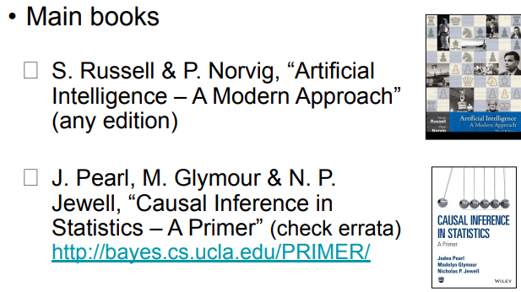

**Acting humanly - Turing Test**

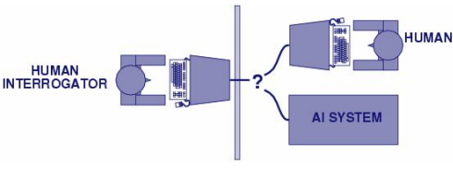

**Thinking humanly – cognitive modelling**

**1960s “cognitive revolution” information-processing & psychology.**

**Requires scientific theories of internal activities of the brain.**

**We can validate this by:**

* **Predicting and testing behaviour of human (top-down)**
* **Direct identification from neurological data (bottom-up)**

**Both approaches 1. Cognitive science 2. Cognitive neuroscience, are now distinct from AI.**

**Thinking rationally – Laws of thought**

Aristotle – What are correct argument/ thought processes?

Several Greek schools developed various forms of logic: notation and rules of derivation for thoughts

Direct line through mathematics and philosophy to modern AI

Problems:

Not all intelligent behaviour is mediated by logical deliberation (e.g. reflex action)

What is the purpose of thinking? Which thoughts should I have?

**Acting rationally – rational agent**

Rational behaviour: doing the right thing!

The right thing: that which is expected to maximise goal achievement, given the available information

Doesn’t necessarily involve thinking – e.g. blinking reflex – but thinking should be in the service of rational action.

AI roots

* Philosophy - Logic, methods of reasoning, mind as physical system foundations of learning, language, rationality
* Mathematics - Formal representation and proof algorithms, computation, (un)decidability, (in)tractability, probability
* Economics - utility, decision theory
* Neuroscience - physical substrate for mental activity
* Psychology - phenomena of perception and motor control, experimental techniques
* Computer engineering - building fast computers
* Control theory - design systems that maximize an objective function over time
* Linguistics - knowledge representation, grammar

AI History

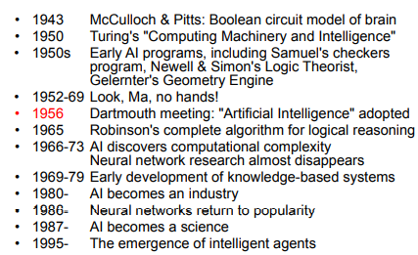

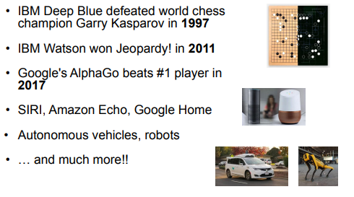

<https://ai.stanford.edu/~nilsson/>

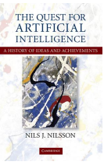

**Rational agents**

An agent is an entity that perceives and acts

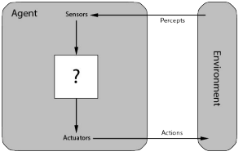

Rational agents

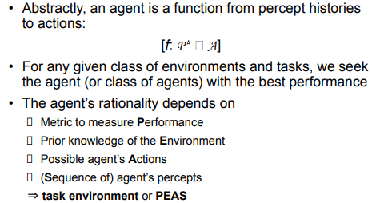

**Task Environment**

